Experiment 1 - Installation of Maven and Gradle

🛠️ Prerequisites

1. Install Java 17 (or higher)
sudo apt update
sudo apt install openjdk-17-jdk -y

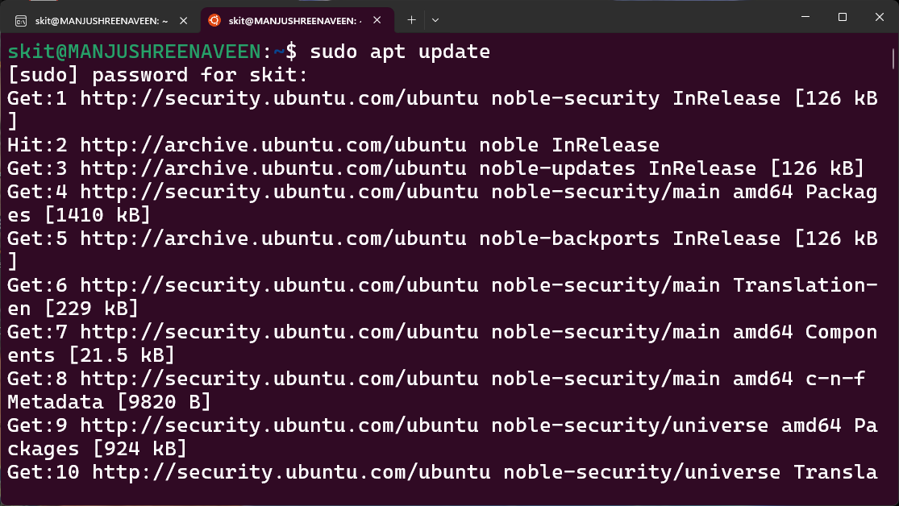

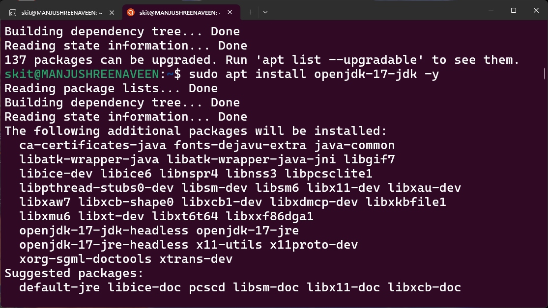

2. Verify Java Installation
java --version

3. Set Java 17 (or higher) as Default if it’s not already set
sudo update-alternatives --config java
Follow the prompts to select Java 17 (or higher).
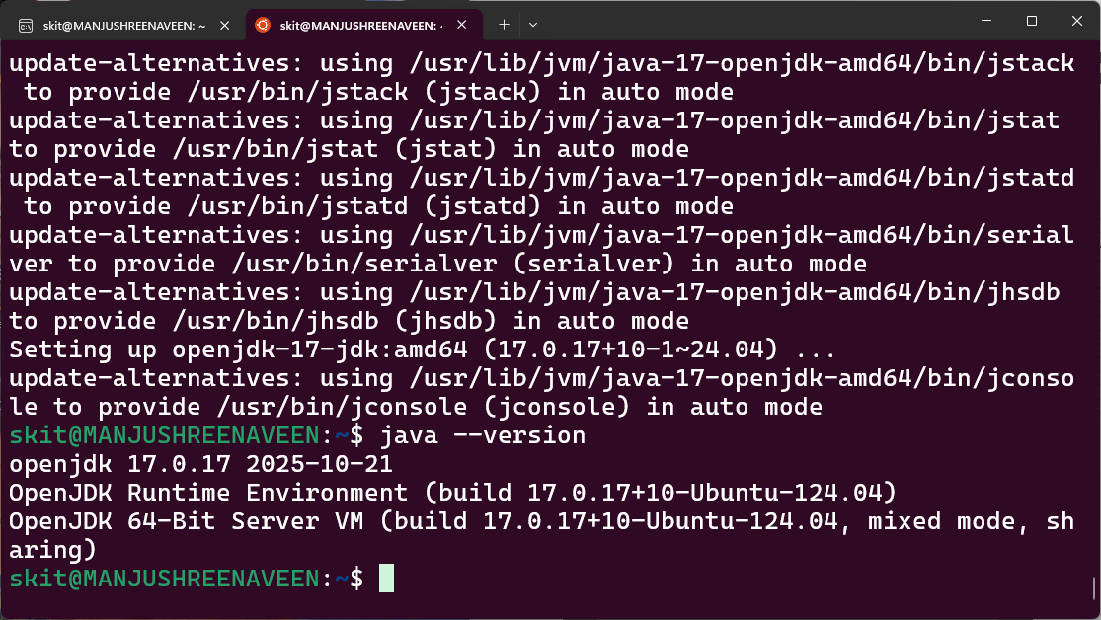

🧹 Remove Existing Gradle (Only if Present)

1. Check if Gradle is Installed
gradle -v

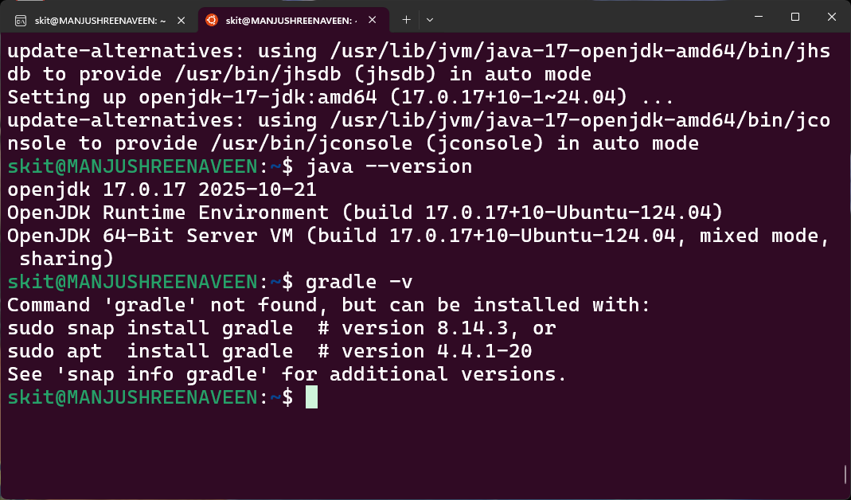
If gradle is installed then follow the following steps to remove the exsisting gradle -

2. Remove Gradle Installed via APT
sudo apt remove gradle -y

3. Remove Gradle Installed via SDKMAN
First check if SDKMAN is installed:
ls ~/.sdkman
If it exists, then uninstall Gradle using:
sdk uninstall gradle <version?> --force

#Replace <version> with the installed version for example if version was 8.13 the line would be -
#sdk uninstall gradle 8.13 —force

📦 Install Maven

1. Install Maven
sudo apt install maven -y

2. Verify Maven Installation
mvn -version
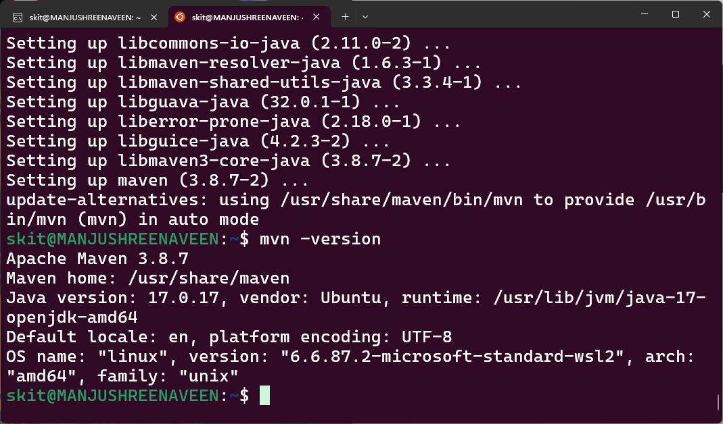

📦 Install Gradle 8.14

1. Download and Extract Gradle
wget <https://services.gradle.org/distributions/gradle-8.14-bin.zip> -P /tmp
sudo unzip -d /opt/gradle /tmp/gradle-8.14-bin.zip

2. Set Environment Variables Permanently (for Bash)

Modify bash command file by running the following command:
gedit ~/.bashrc
At the end of the file, add the following lines:
export GRADLE_HOME=/opt/gradle/gradle-8.14
export PATH=${GRADLE_HOME}/bin:${PATH}
Save the file.
Then to apply the changes run the following in terminal:
source ~/.bashrc

3. Verify Gradle Installation
